ORBIT Developer Guide (SFDX Workflow)

1. Setup Environment (if not done yet)

🔹 1.1 CLI Installation

🍎 macOS Terminal
- Open Terminal
- Paste the commands:
npm install -g @salesforce/cli
Verify:
sf –version
👉 You should see version output like:
@salesforce/cli/x.x.x

🟦 Windows
- Command Prompt / PowerShell / Windows Terminal
- Paste the same commands:
npm install -g @salesforce/cli
Verify:
sf –version
👉 You should see version output like:
@salesforce/cli/x.x.x

⚠️ Common issues

❌ “npm not found”
👉 Node.js not installed
➡️ Install Node.js first:
https://nodejs.org/

❌ Permission error (Mac/Linux)
Try:

sudo npm install -g @salesforce/cli

🔹 1.2 Install VS Code Extensions
- Salesforce Extension Pack
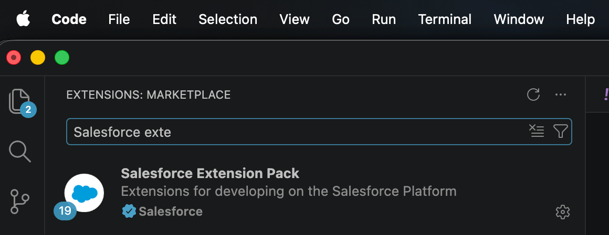
- Salesforce Org Browser
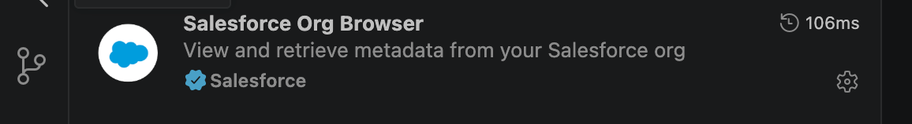
- Salesforce Package.xml Generator Extension for VS Code

2. Authenticate to Salesforce (if not done yet)

🔹 2.1 Login to DEVRR (Sandbox)
Open a terminal and run:

sf org login web --alias devrr --instance-url https://test.salesforce.com

🔹 2.2 Complete Login in Browser
- Browser opens automatically 🌐
- Log in with your Salesforce credentials
- Approve access if prompted

🔹 2.3 Verify Authentication
In terminal and run:
sf org list
✅ Expected:
│ Type │ Alias │ Username │ Org Id │ Status
│ Sandbox │devrr │ eXXXXXX@orbit.ucb.com.devrr │ 00DPw00000IZlkrMAD │ Connected

🔹 2.4 Set Default Org (Recommended)

sf config set target-org=devrr

3. Clone the Repository

Go to Azure ORBIT Repository and open rr branch
https://dev.azure.com/ucbalm/IT%20Commercial/_git/ORBIT?path=%2F&version=GBrr&_a=contents
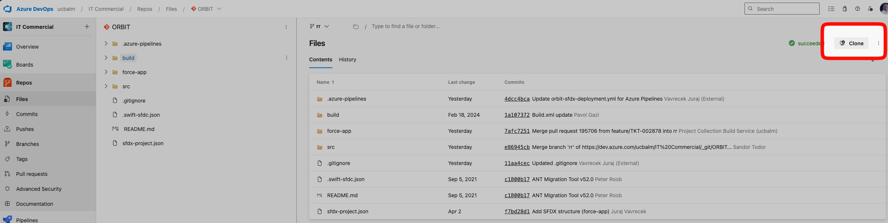
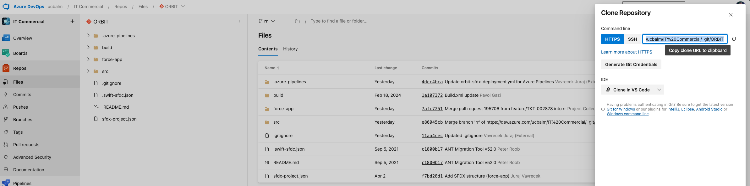
Copy the URL and continue with the local repo creation below.

🟦 OPTION 1: VS Code

🔹 Method A — via Command Palette
- Open VS Code
- Press: Ctrl + Shift + P
- Git: Clone
- Paste the URL (Ctrl + V)
- Choose local folder
- Click Open

🔹 Method B — Welcome Screen
- Click “Clone Git Repository”
- Paste URL
- Select folder

🟩 OPTION 2: SourceTree

🔹 Steps
- Open SourceTree
- Click “Clone” button

🔹 Fill fields
- Source URL → paste repo URL
- Destination Path → choose folder
- Name → auto-filled (ORBIT)
- Clone

⚠️ ️ If it says the URL is not valid, try to change the URL from:
https://ucbalm@dev.azure.com/ucbalm/IT%20Commercial/_git/ORBIT
to
https://dev.azure.com/ucbalm/IT%20Commercial/_git/ORBIT

4. Project Structure

Use: force-app/
Do NOT use: src/ (legacy)

5. Start Development

🔹 Method A — In VS Code Terminal:
git checkout rr
git pull
git checkout -b feature/<your-feature>
Example: git checkout -b feature/US-1234
🔹 Method B — In VS Code via extension
Checkout rr

Run Command (🟦 Windows / Linux CTRL+SHIFT+P 🍎 Mac Cmd + Shift + P)
Git: Pull (you take all the latest changes from Azure rr to your local rr)
Create a feature/ branch (the only place where you develop locally)
Create from remote(origin) rr or local rr (that should be already pulled from origin)
🔹 Method C — In Source Tree
Double click on Branches -> rr
Or right click on Brances -> rr and Checkout rr
Pull from remote rr
Create a feature/ branch (the only place where you develop locally)
Right click on Branches -> New Branch
Or Branch icon from Top icons

6. Daily Development
(All development in force-app/ of the local feature/ branch)
Model:
6.1 DevRR (UI changes Setup → Objects, Flows, etc.)
↓
6.2 Retrieve to local feature branch
↓
6.3 Commit & push
↓
6.4 Pipeline → auto PR creation → auto deploy to CI

🟦 6.1 Make Changes in DevRR (UI)
- Perform changes directly in Devrr:
  - Objects (fields, layouts)
  - Flows
  - Validation rules
  - etc.

🟦 6.2 Retrieve Changes to Local feature branch
🔹 Method A — In VS Code via extension
Run Command (🟦 Windows / Linux CTRL+SHIFT+P 🍎 Mac Cmd + Shift + P)
Choose the component you develop on and retrieve by clicking on the icon
Component will be added to your local feature branch SFDX repo
🔹 Method B — In VS Code via CLI commands in Terminal
sf project retrieve start --metadata <MetadataType>:<Name> --target-org devrr
Examples:
sf project retrieve start --metadata CustomObject:Account --target-org devrr

sf project retrieve start --metadata Flow:My_Flow --target-org devrr

🔹 Method C — Use Git-Hub Copilot/ IBM Bob

🔹 Method D – Recommended for PROFILES retrieval
For Profile changes related to new/updated features, you must specifically retrieve it by using Salesforce Package.xml Generator Extension for VS Code:

Where you:
- Select all UCB Profiles and all components that have impact on the Profiles
- to use ‘UPDATE PACKAGE.XML’ button to create/update package.xml in manifest folder of your local repo (in case manifest folder doesn’t exist in your local repo, create it at the same hierarchy level as force-app)

- right click on the updated package.xml and chose SFDX: Retrieve Source in Manifest from Org

- Then you stage hunks containing your FLS/Layout Assignment/Tab/Class access... changes. Do not commit removed/red lines that are not part of your feature/xxx development (They may come from other Developers if you pulled them).
⚠ You shouldn’t commit the package.xml as it only helps you to retrieve all changes in Profiles.

🟦 6.3 Commit & Push
🔹 Method A — In VS Code
Click Source Control icon from the left menu
Review the list of Changes and use + icon to stage changes
Fill the git commit note and from the Commit arrow menu choose Commit & Push
🔹 Method B — Source Tree
Click File Status from the left menu
Review the list of Unstaged files and use the button to add required changes to Staged files.
Use the Commit Options window to fill the note, check Push immediately box and Commit button.

7. Automated Flow

7.1 New Changes Process
Once you commit and push your changes there are two automated Pipelines triggered in Azure:
- ORBIT Auto PR creates and completes the Pull Request from your Commit and merges new changes to remote rr repository in case there are no conflicts. You should be notified about the completion via email.

- ORBIT SFDX Deployment deploys the new changes to CI once the Pull Request is completed successfully or anything changes in remote rr repository. You should be notified about the completion via email.

Automated flow is like:
commited feature/US-1234 → PR completion → Merge to rr → CI deploy

7.2 Destructive Changes Process
When metadata needs to be permanently removed from Salesforce (for example Apex Classes, Custom Fields, Permission Sets, etc.), the components must be listed in manifest/destructiveChanges.xml and committed together with the related metadata changes.
During deployment:
- Metadata is deployed first.
- The pipeline executes the destructive deployment using manifest/destructiveChanges.xml.
- If the destructive deployment succeeds, the pipeline automatically:
  - Archives the executed destructive package to manifest/destructive-archive/.
  - Names the archive file using the deployment date and tag (for example 2026-06-05_RR_00023.xml).
  - Resets manifest/destructiveChanges.xml to an empty template.
  - Commits the archive back to the rr branch.
This ensures that:
- Destructive changes are executed only once.
- A complete history of all deletions is retained in Git.
- Future deployments are not blocked by attempts to delete already removed metadata.

Deploying Archived Deletions to Another Environment
Archived destructive changes are not executed automatically in ACC, PROD, or other environments.
If the same deletion must be performed in another environment, the required entries must be copied from the appropriate file in manifest/destructive-archive/ back into manifest/destructiveChanges.xml before deployment.

⚠ Common issues

BUILD #20260412.2 FAILED

(email notification)
ORBIT Auto PR identified a conflict in your committed changes, so you must create the Pull Request manually and to resolve conflict(s) before the PR can be completed and changes merged to remote rr repository.
- Go to ORBIT Repository on Azure: https://dev.azure.com/ucbalm/IT%20Commercial/_git/ORBIT
- Pull requests from the left menu.
- In Active tab you should see your commit from which you must create a new Pull Request.
- Then in the PR Conflicts tab you must resolve the conflict by choosing the left or right choice that will complete the PR, merge changes to remote rr repo and trigger the ORBIT SFDX Deployment.

Conflicts can appear for Profiles even if you haven’t committed it.

In case you haven’t pulled the latest Profile files from the remote rr for some time, Pull Request can show Merge Conflicts. As long as you haven’t committed any Profile changes you can use common Profiles folder’s 3 dots ... menu and select ‘Keep Target (rr)’ to keep all remote Profile files untouched and merge only your actual changes.
Then you click OK and Complete the Pull Request.

Rules
DO NOT use src/ folder at all
DO NOT commit to rr
ALWAYS use feature branches
ALWAYS use force-app

Quick Commands
git checkout rr
git pull
git checkout -b feature/my-change
git add .
git commit -m "SFDX: my change"
git push origin feature/my-change

